**Git Assignment**

Name: Nishar Ahamed

**Section 0:**

nisha@NISHAR MINGW64 /d

$ mkdir project_dir

nisha@NISHAR MINGW64 /d

$ cd project_dir

nisha@NISHAR MINGW64 /d/project_dir

$ git init

Initialized empty Git repository in D:/project_dir/.git/

nisha@NISHAR MINGW64 /d/project_dir (master)

$ touch index.html

nisha@NISHAR MINGW64 /d/project_dir (master)

$ git status

On branch master

No commits yet

Untracked files:

(use "git add <file>..." to include in what will be committed)

index.html

nothing added to commit but untracked files present (use "git add" to track)

nisha@NISHAR MINGW64 /d/project_dir (master)

$ git add index.html

nisha@NISHAR MINGW64 /d/project_dir (master)

$ git commit -m 'First commit'

[master (root-commit) adbe815] First commit

1 file changed, 0 insertions(+), 0 deletions(-)

create mode 100644 index.html

nisha@NISHAR MINGW64 /d/project_dir (master)

$ vim index.html

nisha@NISHAR MINGW64 /d/project_dir (master)

$ touch info.txt

nisha@NISHAR MINGW64 /d/project_dir (master)

$ git status

On branch master

Changes not staged for commit:

(use "git add <file>..." to update what will be committed)

(use "git restore <file>..." to discard changes in working directory)

modified: index.html

Untracked files:

(use "git add <file>..." to include in what will be committed)

info.txt

no changes added to commit (use "git add" and/or "git commit -a")

nisha@NISHAR MINGW64 /d/project_dir (master)

$ touch .gitignore

nisha@NISHAR MINGW64 /d/project_dir (master)

$ vim .gitignore

nisha@NISHAR MINGW64 /d/project_dir (master)

$ git status

On branch master

Changes not staged for commit:

(use "git add <file>..." to update what will be committed)

(use "git restore <file>..." to discard changes in working directory)

modified: index.html

Untracked files:

(use "git add <file>..." to include in what will be committed)

.gitignore

no changes added to commit (use "git add" and/or "git commit -a")

nisha@NISHAR MINGW64 /d/project_dir (master)

$ vim .gitignore

nisha@NISHAR MINGW64 /d/project_dir (master)

$ git status

On branch master

Changes not staged for commit:

(use "git add <file>..." to update what will be committed)

(use "git restore <file>..." to discard changes in working directory)

modified: index.html

no changes added to commit (use "git add" and/or "git commit -a")

nisha@NISHAR MINGW64 /d/project_dir (master)

$ git commit -a -m 'few changes are made'

warning: LF will be replaced by CRLF in index.html.

The file will have its original line endings in your working directory

[master c210b99] few changes are made

1 file changed, 1 insertion(+)

nisha@NISHAR MINGW64 /d/project_dir (master)

$ git log

commit c210b990c1610baf57bf2fd0e0ff628bcc40fa0d (HEAD -> master)

Author: NisharAhamedB <nisharahamed01@gmail.com>

Date: Sun Jul 4 15:17:44 2021 +0530

few changes are made

commit adbe81565c677b98525ad092aca90720c2a32cae

Author: NisharAhamedB <nisharahamed01@gmail.com>

Date: Sun Jul 4 15:14:48 2021 +0530

First commit

nisha@NISHAR MINGW64 /d/project_dir (master)

$ vim index.html

nisha@NISHAR MINGW64 /d/project_dir (master)

$ git restore index.html

nisha@NISHAR MINGW64 /d/project_dir (master)

$ vim index.html

nisha@NISHAR MINGW64 /d/project_dir (master)

$ git add index.html

nisha@NISHAR MINGW64 /d/project_dir (master)

$ git checkout -- index.html

nisha@NISHAR MINGW64 /d/project_dir (master)

$ git config --global alias.my-add add

nisha@NISHAR MINGW64 /d/project_dir (master)

$ git my-add index.html

nisha@NISHAR MINGW64 /d/project_dir (master)

$ git commit -m 'New changes'

[master 986fd15] New changes

1 file changed, 1 insertion(+), 1 deletion(-)

nisha@NISHAR MINGW64 /d/project_dir (master)

$ git log

commit 986fd15d76821e3643a9b26a54ac3dcd7dd6f0d9 (HEAD -> master)

Author: NisharAhamedB <nisharahamed01@gmail.com>

Date: Sun Jul 4 15:23:39 2021 +0530

New changes

commit c210b990c1610baf57bf2fd0e0ff628bcc40fa0d

Author: NisharAhamedB <nisharahamed01@gmail.com>

Date: Sun Jul 4 15:17:44 2021 +0530

few changes are made

commit adbe81565c677b98525ad092aca90720c2a32cae

Author: NisharAhamedB <nisharahamed01@gmail.com>

Date: Sun Jul 4 15:14:48 2021 +0530

First commit

nisha@NISHAR MINGW64 /d/project_dir (master)

$ ^C

nisha@NISHAR MINGW64 /d/project_dir (master)

$ git revert 986fd15d76821e3643a9b26a54ac3dcd7dd6f0d9

[master 36aa501] Revert "New changes"

1 file changed, 1 insertion(+), 1 deletion(-)

**Section 1**

nisha@NISHAR MINGW64 /d/project_dir (master)

$ mkdir Assignments

nisha@NISHAR MINGW64 /d/project_dir (master)

$ cd Assignments

nisha@NISHAR MINGW64 /d/project_dir/Assignments (master)

$ touch README.txt

nisha@NISHAR MINGW64 /d/project_dir/Assignments (master)

$ vim README.txt

nisha@NISHAR MINGW64 /d/project_dir/Assignments (master)

$ vim README.txt

nisha@NISHAR MINGW64 /d/project_dir/Assignments (master)

$ git add README.txt

The following paths are ignored by one of your .gitignore files:

Assignments/README.txt

hint: Use -f if you really want to add them.

hint: Turn this message off by running

hint: "git config advice.addIgnoredFile false"

nisha@NISHAR MINGW64 /d/project_dir/Assignments (master)

$ vim .gitignore

nisha@NISHAR MINGW64 /d/project_dir/Assignments (master)

$ cd project_dir

bash: cd: project_dir: No such file or directory

nisha@NISHAR MINGW64 /d/project_dir/Assignments (master)

$ cd ..

nisha@NISHAR MINGW64 /d/project_dir (master)

$ vim .gitignore

nisha@NISHAR MINGW64 /d/project_dir (master)

$ cd Assignments

nisha@NISHAR MINGW64 /d/project_dir/Assignments (master)

$ git add README.txt

warning: LF will be replaced by CRLF in Assignments/README.txt.

The file will have its original line endings in your working directory

nisha@NISHAR MINGW64 /d/project_dir/Assignments (master)

$ git status

On branch master

Changes to be committed:

(use "git restore --staged <file>..." to unstage)

new file: README.txt

Untracked files:

(use "git add <file>..." to include in what will be committed)

../info.txt

nisha@NISHAR MINGW64 /d/project_dir/Assignments (master)

$ git commit -m 'new commit'

[master 3d16f23] new commit

1 file changed, 1 insertion(+)

create mode 100644 Assignments/README.txt

nisha@NISHAR MINGW64 /d/project_dir/Assignments (master)

$ git branch html-assignments

nisha@NISHAR MINGW64 /d/project_dir/Assignments (master)

$ git checkout html-assignments

Switched to branch 'html-assignments'

nisha@NISHAR MINGW64 /d/project_dir/Assignments (html-assignments)

$ touch file1.html file.2 html

nisha@NISHAR MINGW64 /d/project_dir/Assignments (html-assignments)

$ vim file1.html

nisha@NISHAR MINGW64 /d/project_dir/Assignments (html-assignments)

$ vim file2.html

nisha@NISHAR MINGW64 /d/project_dir/Assignments (html-assignments)

$ git add .

warning: LF will be replaced by CRLF in Assignments/file1.html.

The file will have its original line endings in your working directory

warning: LF will be replaced by CRLF in Assignments/file2.html.

The file will have its original line endings in your working directory

nisha@NISHAR MINGW64 /d/project_dir/Assignments (html-assignments)

$ git commit -m 'first commit in html branch'

[html-assignments bea8b3e] first commit in html branch

4 files changed, 2 insertions(+)

create mode 100644 Assignments/file.2

create mode 100644 Assignments/file1.html

create mode 100644 Assignments/file2.html

create mode 100644 Assignments/html

nisha@NISHAR MINGW64 /d/project_dir/Assignments (html-assignments)

$ vim file1.html

nisha@NISHAR MINGW64 /d/project_dir/Assignments (html-assignments)

$ vim file2.html

nisha@NISHAR MINGW64 /d/project_dir/Assignments (html-assignments)

$ git commit -a -m 'new changes in html files'

warning: LF will be replaced by CRLF in Assignments/file1.html.

The file will have its original line endings in your working directory

warning: LF will be replaced by CRLF in Assignments/file2.html.

The file will have its original line endings in your working directory

[html-assignments ab9ed71] new changes in html files

2 files changed, 2 insertions(+), 2 deletions(-)

nisha@NISHAR MINGW64 /d/project_dir/Assignments (html-assignments)

$ git checkout master

Switched to branch 'master'

nisha@NISHAR MINGW64 /d/project_dir/Assignments (master)

$ vim README.txt

nisha@NISHAR MINGW64 /d/project_dir/Assignments (master)

$ git commit -a -m 'new changes in master files'

warning: LF will be replaced by CRLF in Assignments/README.txt.

The file will have its original line endings in your working directory

[master a83a811] new changes in master files

1 file changed, 1 insertion(+), 1 deletion(-)

nisha@NISHAR MINGW64 /d/project_dir/Assignments (master)

$ git checkout html-assignments

Switched to branch 'html-assignments'

nisha@NISHAR MINGW64 /d/project_dir/Assignments (html-assignments)

$ vim file1.html

nisha@NISHAR MINGW64 /d/project_dir/Assignments (html-assignments)

$ vim file2.html

nisha@NISHAR MINGW64 /d/project_dir/Assignments (html-assignments)

$ git commit -a -m 'new other changes in files'

[html-assignments 693ddbe] new other changes in files

2 files changed, 2 insertions(+), 2 deletions(-)

nisha@NISHAR MINGW64 /d/project_dir/Assignments (html-assignments)

$ git checkout master

Switched to branch 'master'

nisha@NISHAR MINGW64 /d/project_dir/Assignments (master)

$ git merge html-assignments

Merge made by the 'recursive' strategy.

Assignments/file.2 | 0

Assignments/file1.html | 1 +

Assignments/file2.html | 1 +

Assignments/html | 0

4 files changed, 2 insertions(+)

create mode 100644 Assignments/file.2

create mode 100644 Assignments/file1.html

create mode 100644 Assignments/file2.html

create mode 100644 Assignments/html

nisha@NISHAR MINGW64 /d/project_dir/Assignments (master)

$ git branch --merged

html-assignments

* master

nisha@NISHAR MINGW64 /d/project_dir/Assignments (master)

$ git branch -d html-assignments

Deleted branch html-assignments (was 693ddbe).

**Section 2**

nisha@NISHAR MINGW64 /d/project_dir/Assignments (master)

$ git branch css-assignments

nisha@NISHAR MINGW64 /d/project_dir/Assignments (master)

$ git checkout css-assignments

Switched to branch 'css-assignments'

nisha@NISHAR MINGW64 /d/project_dir/Assignments (css-assignments)

$ touch file1.css file2.css

nisha@NISHAR MINGW64 /d/project_dir/Assignments (css-assignments)

$ vim file1.css

nisha@NISHAR MINGW64 /d/project_dir/Assignments (css-assignments)

$ vim file2.css

nisha@NISHAR MINGW64 /d/project_dir/Assignments (css-assignments)

$ git add .

warning: LF will be replaced by CRLF in Assignments/file1.css.

The file will have its original line endings in your working directory

warning: LF will be replaced by CRLF in Assignments/file2.css.

The file will have its original line endings in your working directory

nisha@NISHAR MINGW64 /d/project_dir/Assignments (css-assignments)

$ git commit -m 'new files for css assignment'

[css-assignments a4386df] new files for css assignment

2 files changed, 2 insertions(+)

create mode 100644 Assignments/file1.css

create mode 100644 Assignments/file2.css

nisha@NISHAR MINGW64 /d/project_dir/Assignments (css-assignments)

$ vim README.txt

nisha@NISHAR MINGW64 /d/project_dir/Assignments (css-assignments)

$ git commit -m 'new change in readme'

On branch css-assignments

Changes not staged for commit:

(use "git add <file>..." to update what will be committed)

(use "git restore <file>..." to discard changes in working directory)

modified: README.txt

Untracked files:

(use "git add <file>..." to include in what will be committed)

../info.txt

no changes added to commit (use "git add" and/or "git commit -a")

nisha@NISHAR MINGW64 /d/project_dir/Assignments (css-assignments)

$ git add .

nisha@NISHAR MINGW64 /d/project_dir/Assignments (css-assignments)

$ git commit -m 'new change in readme'

[css-assignments 121a7f7] new change in readme

1 file changed, 1 insertion(+), 1 deletion(-)

nisha@NISHAR MINGW64 /d/project_dir/Assignments (css-assignments)

$ git checkout master

Switched to branch 'master'

nisha@NISHAR MINGW64 /d/project_dir/Assignments (master)

$ vim README.txt

nisha@NISHAR MINGW64 /d/project_dir/Assignments (master)

$ git commit -a -m 'new change in readme'

[master f6c4751] new change in readme

1 file changed, 2 insertions(+)

nisha@NISHAR MINGW64 /d/project_dir/Assignments (master)

$ git checkout css-assignmets

error: pathspec 'css-assignmets' did not match any file(s) known to git

nisha@NISHAR MINGW64 /d/project_dir/Assignments (master)

$ git checkout css-assignments

Switched to branch 'css-assignments'

nisha@NISHAR MINGW64 /d/project_dir/Assignments (css-assignments)

$ vim file1.css

nisha@NISHAR MINGW64 /d/project_dir/Assignments (css-assignments)

$ vim file2.css

nisha@NISHAR MINGW64 /d/project_dir/Assignments (css-assignments)

$ git commit -a -m 'new change in css files'

[css-assignments a126d72] new change in css files

2 files changed, 2 insertions(+), 2 deletions(-)

nisha@NISHAR MINGW64 /d/project_dir/Assignments (css-assignments)

$ git checkout master

Switched to branch 'master'

nisha@NISHAR MINGW64 /d/project_dir/Assignments (master)

$ git merge css-assignments

Auto-merging Assignments/README.txt

CONFLICT (content): Merge conflict in Assignments/README.txt

Automatic merge failed; fix conflicts and then commit the result.

nisha@NISHAR MINGW64 /d/project_dir/Assignments (master|MERGING)

$ git status

On branch master

You have unmerged paths.

(fix conflicts and run "git commit")

(use "git merge --abort" to abort the merge)

Changes to be committed:

new file: file1.css

new file: file2.css

Unmerged paths:

(use "git add <file>..." to mark resolution)

both modified: README.txt

Untracked files:

(use "git add <file>..." to include in what will be committed)

../info.txt

nisha@NISHAR MINGW64 /d/project_dir/Assignments (master|MERGING)

$ git merge --abort

nisha@NISHAR MINGW64 /d/project_dir/Assignments (master)

$ git status

On branch master

Untracked files:

(use "git add <file>..." to include in what will be committed)

../info.txt

nothing added to commit but untracked files present (use "git add" to track)

nisha@NISHAR MINGW64 /d/project_dir/Assignments (master)

$ git checkout css-assignments

Switched to branch 'css-assignments'

nisha@NISHAR MINGW64 /d/project_dir/Assignments (css-assignments)

$ git status

On branch css-assignments

Untracked files:

(use "git add <file>..." to include in what will be committed)

../info.txt

nothing added to commit but untracked files present (use "git add" to track)

nisha@NISHAR MINGW64 /d/project_dir/Assignments (css-assignments)

$ git checkout master

Switched to branch 'master'

nisha@NISHAR MINGW64 /d/project_dir/Assignments (master)

$ git merge css-assignments

Auto-merging Assignments/README.txt

CONFLICT (content): Merge conflict in Assignments/README.txt

Automatic merge failed; fix conflicts and then commit the result.

nisha@NISHAR MINGW64 /d/project_dir/Assignments (master|MERGING)

$ vim README.txt

nisha@NISHAR MINGW64 /d/project_dir/Assignments (master|MERGING)

$ git add .

nisha@NISHAR MINGW64 /d/project_dir/Assignments (master|MERGING)

$ git commit

[master a44604d] Merge branch 'css-assignments'

nisha@NISHAR MINGW64 /d/project_dir/Assignments (master)

$ git branch -d css-assignments

Deleted branch css-assignments (was a126d72).

**Section 3:**

nisha@NISHAR MINGW64 /d/project_dir/Assignments (master)

$ git branch js-assignments

nisha@NISHAR MINGW64 /d/project_dir/Assignments (master)

$ git checkout js-assignments

Switched to branch 'js-assignments'

nisha@NISHAR MINGW64 /d/project_dir/Assignments (js-assignments)

$ vim file1.js

nisha@NISHAR MINGW64 /d/project_dir/Assignments (js-assignments)

$ vim file2.js

nisha@NISHAR MINGW64 /d/project_dir/Assignments (js-assignments)

$ git add .

warning: LF will be replaced by CRLF in Assignments/file1.js.

The file will have its original line endings in your working directory

warning: LF will be replaced by CRLF in Assignments/file2.js.

The file will have its original line endings in your working directory

nisha@NISHAR MINGW64 /d/project_dir/Assignments (js-assignments)

$ git commit -m 'new commit'

[js-assignments 18a69dc] new commit

2 files changed, 2 insertions(+)

create mode 100644 Assignments/file1.js

create mode 100644 Assignments/file2.js

nisha@NISHAR MINGW64 /d/project_dir/Assignments (js-assignments)

$ vim README.txt

nisha@NISHAR MINGW64 /d/project_dir/Assignments (js-assignments)

$ git commit -a -m 'new change in js readme files'

[js-assignments 57960c1] new change in js readme files

1 file changed, 1 insertion(+), 1 deletion(-)

nisha@NISHAR MINGW64 /d/project_dir/Assignments (js-assignments)

$ git checkout master

Switched to branch 'master'

nisha@NISHAR MINGW64 /d/project_dir/Assignments (master)

$ vim README.txt

nisha@NISHAR MINGW64 /d/project_dir/Assignments (master)

$ git commit -a -m 'new change in master readme files'

[master 3a347bd] new change in master readme files

1 file changed, 1 insertion(+), 1 deletion(-)

nisha@NISHAR MINGW64 /d/project_dir/Assignments (master)

$ git checkout js-assignments

Switched to branch 'js-assignments'

nisha@NISHAR MINGW64 /d/project_dir/Assignments (js-assignments)

$ vim file1.js

nisha@NISHAR MINGW64 /d/project_dir/Assignments (js-assignments)

$ vim file2.js

nisha@NISHAR MINGW64 /d/project_dir/Assignments (js-assignments)

$ git commit -a -m 'new change in master js files'

[js-assignments bca8287] new change in master js files

2 files changed, 2 insertions(+), 2 deletions(-)

nisha@NISHAR MINGW64 /d/project_dir/Assignments (js-assignments)

$ git checkout master

Switched to branch 'master'

nisha@NISHAR MINGW64 /d/project_dir/Assignments (master)

$ git merge js-assignments

Auto-merging Assignments/README.txt

Merge made by the 'recursive' strategy.

Assignments/README.txt | 2 +-

Assignments/file1.js | 1 +

Assignments/file2.js | 1 +

3 files changed, 3 insertions(+), 1 deletion(-)

create mode 100644 Assignments/file1.js

create mode 100644 Assignments/file2.js

nisha@NISHAR MINGW64 /d/project_dir/Assignments (master)

$ git branch -d js-assignments

Deleted branch js-assignments (was bca8287).

nisha@NISHAR MINGW64 /d/project_dir/Assignments (master)

$ git config --global user.name 'NisharAhamedB'

nisha@NISHAR MINGW64 /d/project_dir/Assignments (master)

$ git config --global user.email 'nisharahamed01@gmail.com'

nisha@NISHAR MINGW64 /d/project_dir/Assignments (master)

$ git remote add origin https://github.com/NisharAhamedB/new-freshersbatch-oct16.git

nisha@NISHAR MINGW64 /d/project_dir/Assignments (master)

$ git push -u origin master

Enumerating objects: 74, done.

Counting objects: 100% (74/74), done.

Delta compression using up to 4 threads

Compressing objects: 100% (58/58), done.

Writing objects: 100% (74/74), 6.42 KiB | 243.00 KiB/s, done.

Total 74 (delta 17), reused 0 (delta 0), pack-reused 0

remote: Resolving deltas: 100% (17/17), done.

To https://github.com/NisharAhamedB/new-freshersbatch-oct16.git

* [new branch] master -> master

Branch 'master' set up to track remote branch 'master' from 'origin'.

The files are committed and pushed to remote repository through git.

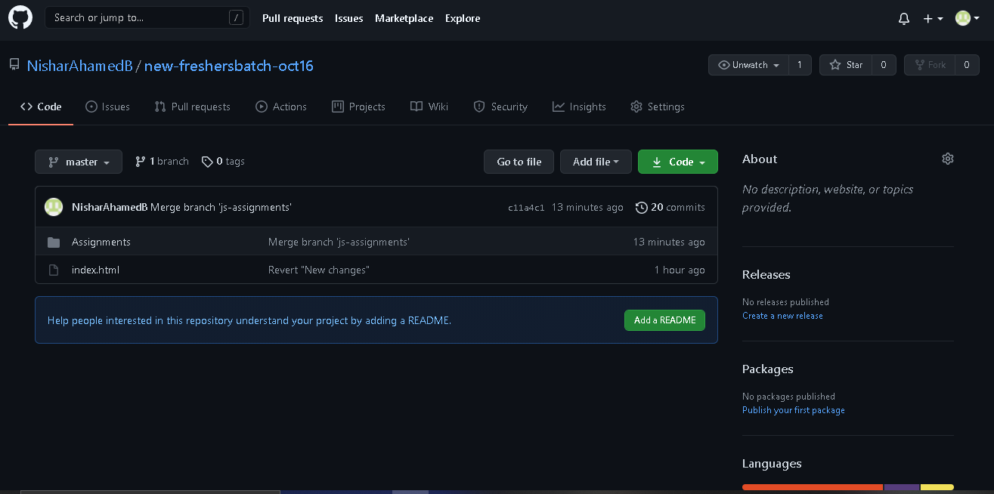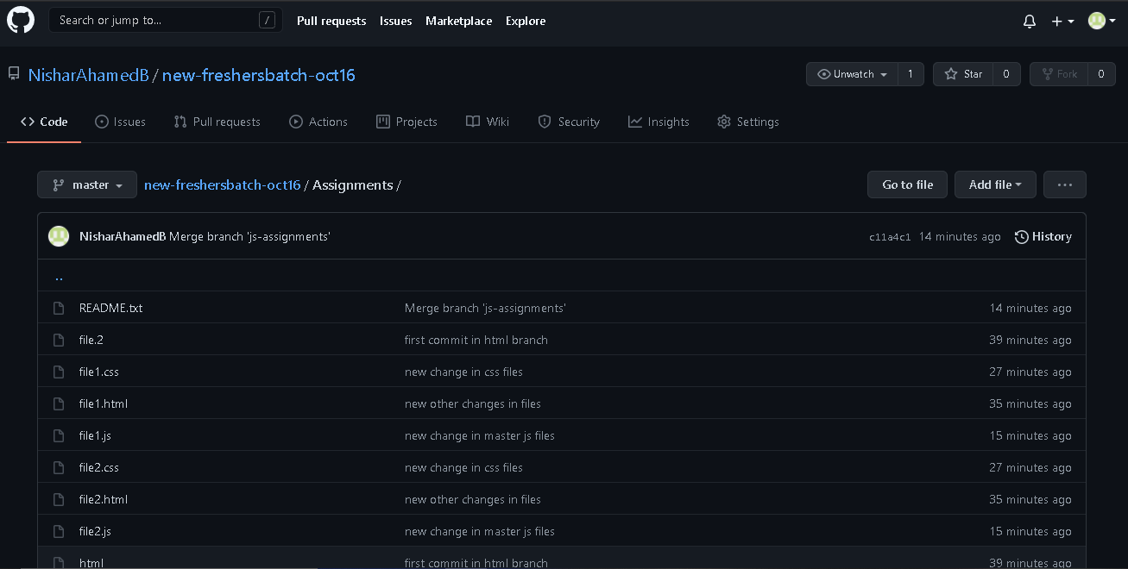

**Section 4:**

A Sample file is committed and pushed through eclipse.

